PART 1: The Challenge
Background: Safely Riding a Car.
You are tasked to design a combinational logic circuit that operates an alarm in a car whenever the driver and/or passenger seats are occupied, and the seatbelts are not fastened when the car is started. The active-HIGH signals DRIV and PASS indicate the presence of the driver and passenger, respectively, and are taken from pressure-actuated switches in the seats. The signal IGN is active-HIGH when the ignition switch is on. The signal 𝐵𝐸𝐿𝑇𝐷̅̅̅̅̅̅̅̅̅̅ is active- LOW and indicates that the driver’s seatbelt is unfastened. 𝐵𝐸𝐿𝑇𝑃̅̅̅̅̅̅̅̅̅ is the corresponding signal for the passenger seatbelt. The alarm will be activated (LOW) whenever the car is started and either of the front seats is occupied and its seatbelt is not fastened. Your goal is to design the logic circuit needed to fulfill the above conditions. You must use the problem-solving process (PSP) taught during the lectures alongside the Boolean design process (BDP). Below is a step-by-step guide to assist you in this endeavour. Your tutors will also assist you in this.
Step 1: Understand and Define the Problem (Analyse)
The system activates an alarm whenever the ignition is on and either the driver or passenger seat is occupied while the corresponding seatbelt signal indicates it is unfastened, using active-HIGH inputs for seat occupancy and ignition, and active-LOW signals to detect unfastened seatbelts.

Step 2: Organise and Describe the Data
Symbol | Meaning | Type | Active Logic
DRIV | Driver is seated | Input | Active High (1 = Presented)
PASS | Passenger is seated | Input | Active High (1 = Presented)
IGN | Ignition is on | Input | Active High (1 = On)
$$\overline{BELTD}$$ | Driver's belt signal | Input | Active Low (0 = Unfastened)
$$\overline{BELTP}$$ | Passenger's belt signal | Input | Active Low(0 = Unfastened)
$$\overline{ALARM}$$ | Alarm signal | Output | Active Low(0 = On)

Step 3: Plan the Solution (Design the Algorithm)
3.1 Algorithm (in plain English)
- Check for ignition button i.e IGN = 1
- If driver is seated and seatbelt not fastened i.e DRIV = 1 and $\overline{BELTD}$ = 0
- If Passenger is seated and seatbelt not fastened i.e PASS = 1 and $\overline{BELTP}$ = 0
- If above conditions are true then $\overline{ALARM}$ signal should be ON.
- Otherwise $\overline{ALARM}$ should be OFF.
3.2 Truth Table
DRIV | PASS | $$\overline{BELTD}$$ | $$\overline{BELTP}$$ | IGN | $$\overline{ALARM}$$
0 | 0 | 0 | 0 | 1 | 1
0 | 0 | 0 | 1 | 1 | 1
0 | 0 | 1 | 0 | 1 | 1
0 | 0 | 1 | 1 | 1 | 1
0 | 1 | 0 | 0 | 1 | 1
0 | 1 | 0 | 1 | 1 | 1
0 | 1 | 1 | 0 | 1 | 1
0 | 1 | 1 | 1 | 1 | 1
1 | 0 | 0 | 0 | 1 | 0 | DRIV . $\overline{PASS } . \overline{BELTD} . \overline{BELTP}$. IGN
1 | 0 | 0 | 1 | 1 | 0 | DRIV . $\overline{PASS } . \overline{BELTD} .$BELTP . IGN
1 | 0 | 1 | 0 | 1 | 1
1 | 0 | 1 | 1 | 1 | 1
1 | 1 | 0 | 0 | 1 | 0 | DRIV . PASS$\overline{BELTD} . \overline{BELTP}$. IGN
1 | 1 | 0 | 1 | 1 | 0 | DRIV . $PASS . \overline{BELTD} .$BELTP . IGN
1 | 1 | 1 | 0 | 1 | 0 | DRIV . PASS $. BELTD . \overline{BELTP}$. IGN
1 | 1 | 1 | 1 | 1 | 1

3.3 Boolean Expressions (SOP)
DRIV . $\overline{PASS } . \overline{BELTD} . \overline{BELTP}$. IGN
DRIV . $\overline{PASS } . \overline{BELTD} .$BELTP . IGN
DRIV . PASS$\overline{BELTD} . \overline{BELTP}$. IGN
DRIV . $PASS . \overline{BELTD} .$BELTP . IGN
DRIV . PASS $. BELTD . \overline{BELTP}$. IGN

$\overline{ALARM}=$DRIV . $\overline{PASS } . \overline{BELTD} . \overline{BELTP}$. IGN + DRIV . $\overline{PASS } . \overline{BELTD} .$BELTP . IGN + DRIV . PASS$\overline{BELTD} . \overline{BELTP}$. IGN + DRIV . $PASS . \overline{BELTD} .$BELTP . IGN + DRIV . PASS $. BELTD . \overline{BELTP}$. IGN

3.4 Flowchart
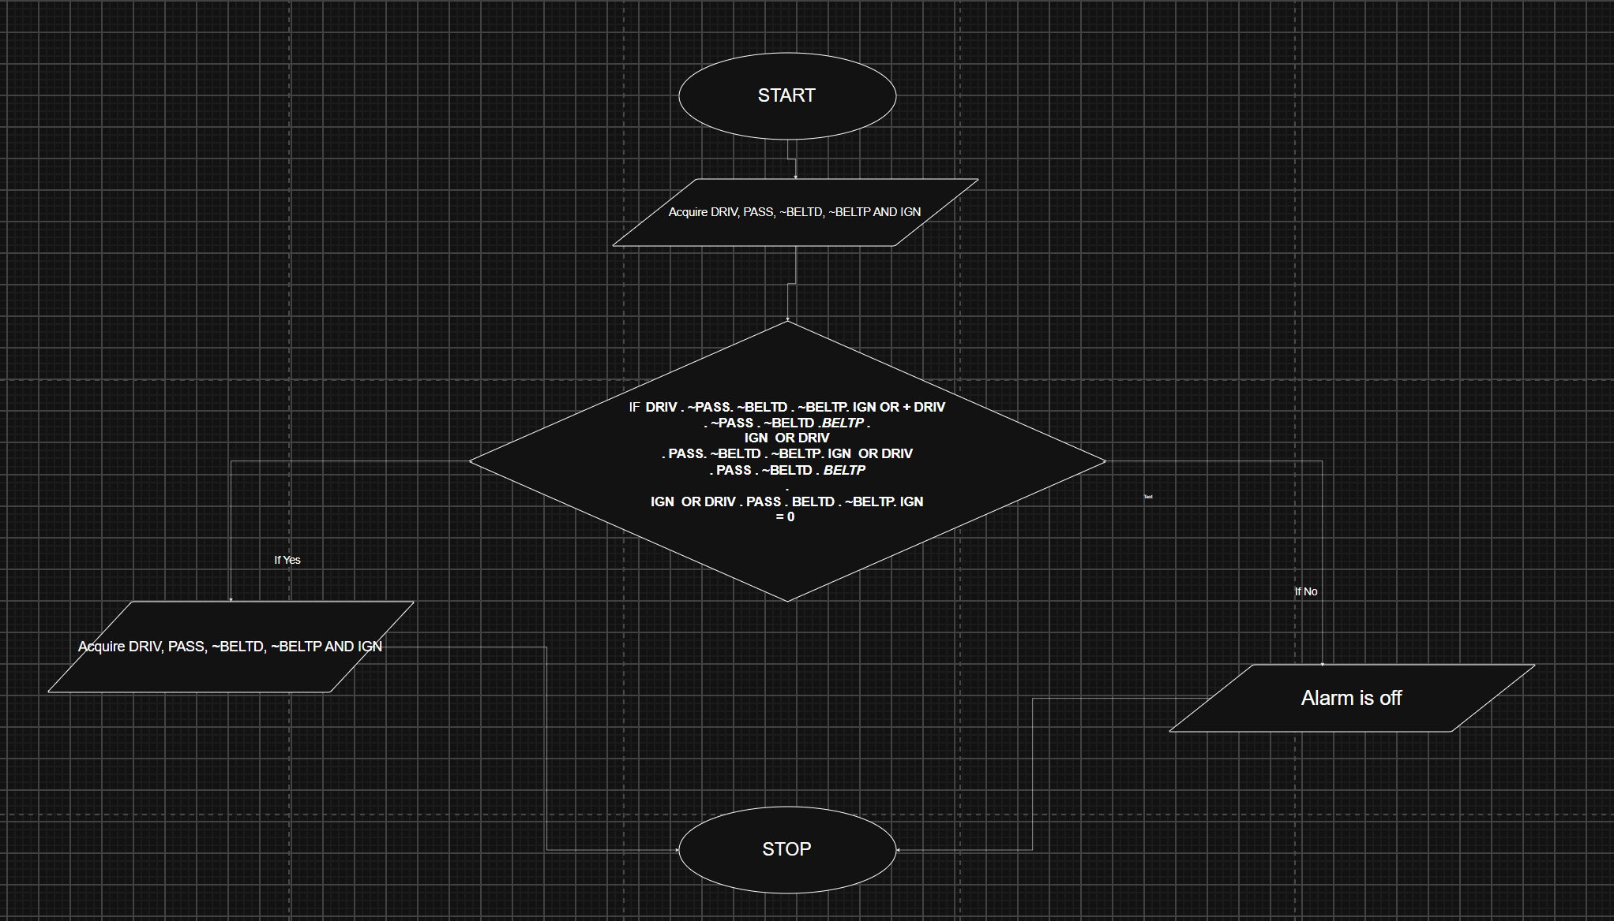
3.5 Pseudocode
IF $=$DRIV . $\overline{PASS } . \overline{BELTD} . \overline{BELTP}$. IGN OR
DRIV . $\overline{PASS } . \overline{BELTD} .$BELTP . IGN OR
DRIV . PASS$\overline{BELTD} . \overline{BELTP}$. IGN OR
DRIV . $PASS . \overline{BELTD} .$BELTP . IGN OR
DRIV . PASS $. BELTD . \overline{BELTP}$. IGN
Then $\overline{ALARM}$goes ON otherwise $\overline{ALARM}$remains OFF

Step 4: Test and Refine the Solution (Debug and Verify)
- DRIV = 1, PASS = 0, $\overline{BELTD} =0 \overline{BELTP}$ = 0 IGN = 1 then $\overline{ALARM}$ = 0
If driver is seated and Driver’s seatbelt is unfastened then Alarm should go ON

